**LEBANESE AMERICAN UNIVERSITY**

**USAID – HIGHER EDUCATION SCHOLARSHIP PROGRAM**

**HES - Volunteering Program Verification Form**

This form is to be used to document volunteering hours. If a student volunteers for multiple organizations, a separate form must be used for each organization. **This form must be turned in by the 28th of each month, the latest.**

I certify that the scholar Ali Hassoun completed a total of 1 hours of service at Life Sculptor.

The hours were completed hours as per the below:

Hours # 0 (date) _30/09 – 5/10_ (initials of supervisor) __A.K.___

Hours # 0 (date) _7/10 – 11/10_ (initials of supervisor) __A.K.___

Hours # 1 date) _14/10 – 18/10 (initials of supervisor) __A.K.___

Hours # 0 date) _21/10 -25/10 (initials of supervisor) __A.K.___

Brief description of the activities the scholar performed or participated in:

Ali is part of our research team. He needs to conduct some research on topics that the   
supervisor of the research team has assigned to him.   
Ali did a research about “What are the key features of team collaboration tools”

Written feedback about the scholar’s performance:

Ali displays a good foundation in research skills and shows potential in information gathering and analysis. Though his contributions are still developing, his ability to start exploring topics with focus reflects a growing aptitude for critical thinking. With further opportunities, Ali can strengthen his attention to detail and engagement with complex subjects.

Please rate the overall performance of the scholar at your organization:

|  |  |  |  |
| --- | --- | --- | --- |
|  | Mastery (5) | Proficient (3) | Emerging (1) |
| **Problem solver** | X |  |  |
| **Engaged & Committed** | X |  |  |
| **Open-minded & multicultural** | X |  |  |

Signature

& stamp

__________________________

_

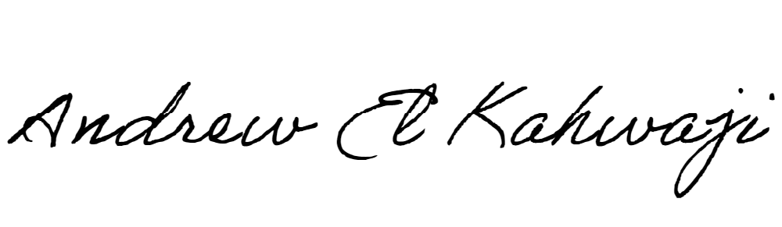

Printed Name _Andrew El Kahwaji_

Date __26/10/2024___

Email __andrew.lifesculptor.coo@gmail.com __

Phone __+961 71 914 378__

**LEBANESE AMERICAN UNIVERSITY**

**USAID – HIGHER EDUCATION SCHOLARSHIP PROGRAM**

